IT 140: INTRODUCTION TO SCRIPTING

Cathrine Karangi

Southern New Hampshire University

IT 140: Introduction To Scripting

Professor: Wayne Sevigny

May 21, 2025

START

// Input

PROMPT "Enter the number of hours worked:" READ hoursWorked

// Initialize constants

SET hourlyRate = 20

SET overtimeRate = 30 SET regularHours = 40 SET totalPay = 0

// Processing

IF hoursWorked <= regularHours THEN totalPay = hoursWorked \* hourlyRate

ELSE

regularPay = regularHours \* hourlyRate overtimeHours = hoursWorked - regularHours overtimePay = overtimeHours \* overtimeRate totalPay = regularPay + overtimePay

ENDIF

// Output

PRINT "Total Pay: $" + totalPay END

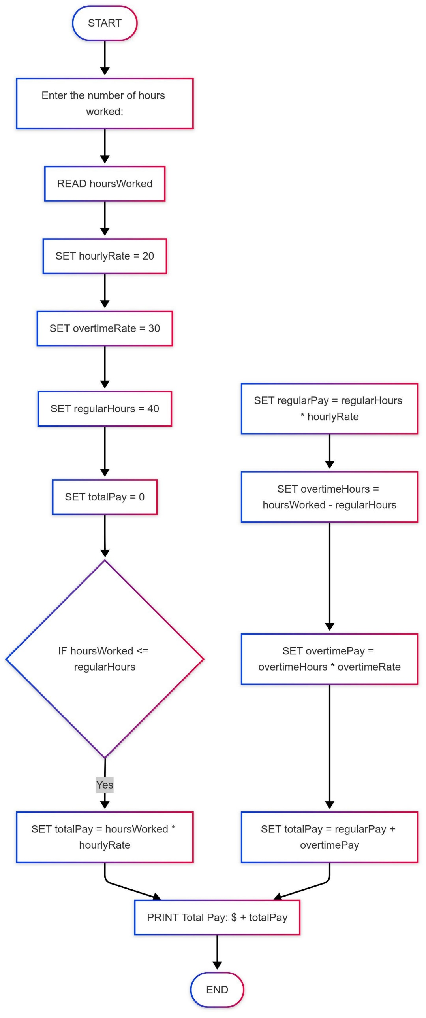

1. Start: "Start" marked oval shape.

2. Input: "Enter the number of hours worked" prompting parallelogram shape.

3. Decision: "Is hours worked <= 40?" prompting diamond shape.

Yes, branch:

Processing step (rectangle) calculation totalPay = hoursWorked \* hourlyRate.

Output step (parallelogram) showing "Total Pay: $" + totalPay.

No branch

Step of calculating regularPay = 40 \* hourlyRate.

Step of calculating overtimeHours = hoursWorked - 40.

Step of calculating overtimePay = overtimeHours \* overtimeRate.

Compute step calculating totalPay = regularPay + overtimePay.

Output step printing "Total Pay: $" + totalPay.

4. End: Oval symbol labeled "End".